Airline Ticket Booking System

Introduction:

In this project user or customer can register and book the flight tickets.it also contains admin side from where manage all the timetables of the flights.

Objective:

The main objective of airline booking system is to manage details of airlines tickets ,Flights ,customer. the purpose of the project is to build an application program to reduce the manual work.

Entity relationship diagram:

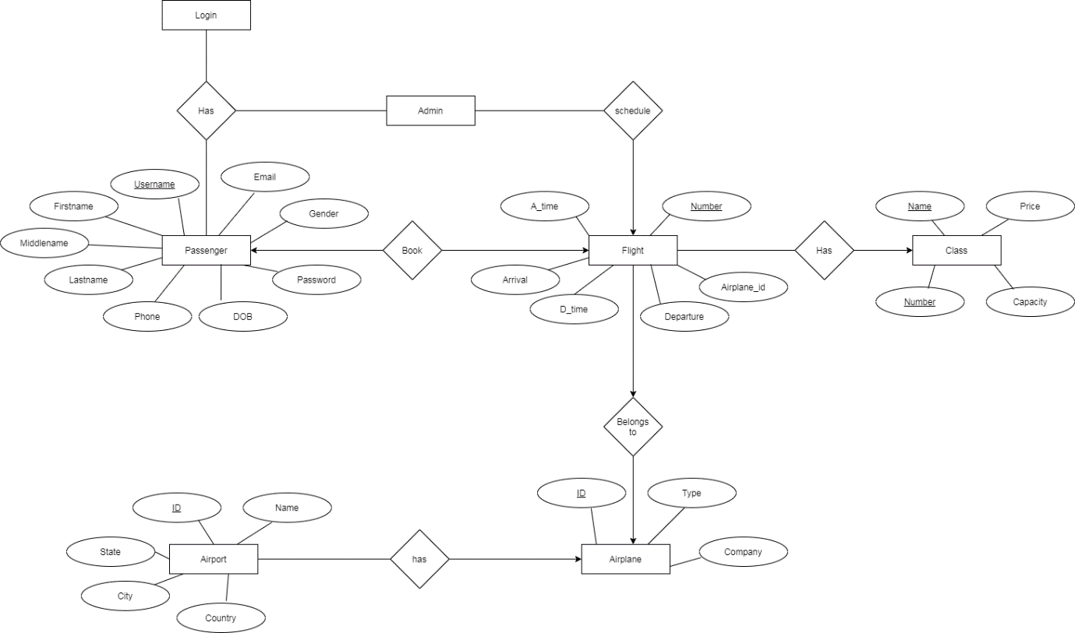

Usecase diagram:

